**REQUIREMENTS**

1. Google Chrome Browser
2. WampServer 2.0i

*Download Link:* <https://sourceforge.net/projects/wampserver/files/WampServer%202/WampServer%202.0/WampServer2.0i.exe/download?use_mirror=jaist&use_mirror=mesh>

**HOW TO SETUP YOUR SYSTEM USING WAMPSERVER**

1. Download the file: <https://drive.google.com/file/d/1wjk1BZ94-5VoqDaYd28AvAO11y7HSKBp/view?usp=sharing>
2. Open **WampServer 2.0i**. Make sure that the WampServer icon in **System Tray** turned **White**.



1. Extract the downloaded file (**OnlinePersonalCounseling[08142021].zip**) anywhere.
2. Open the folder of the extracted .zip file.



1. Copy the **Lakan** folder into **C:\wamp\www\** directory

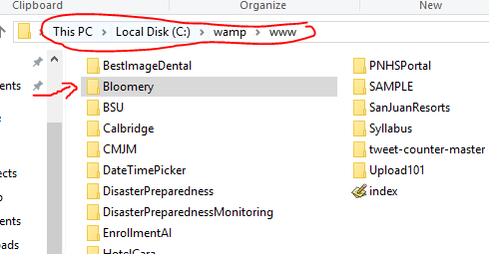

1. Now, open **Google Chrome** browser and access “**localhost**”

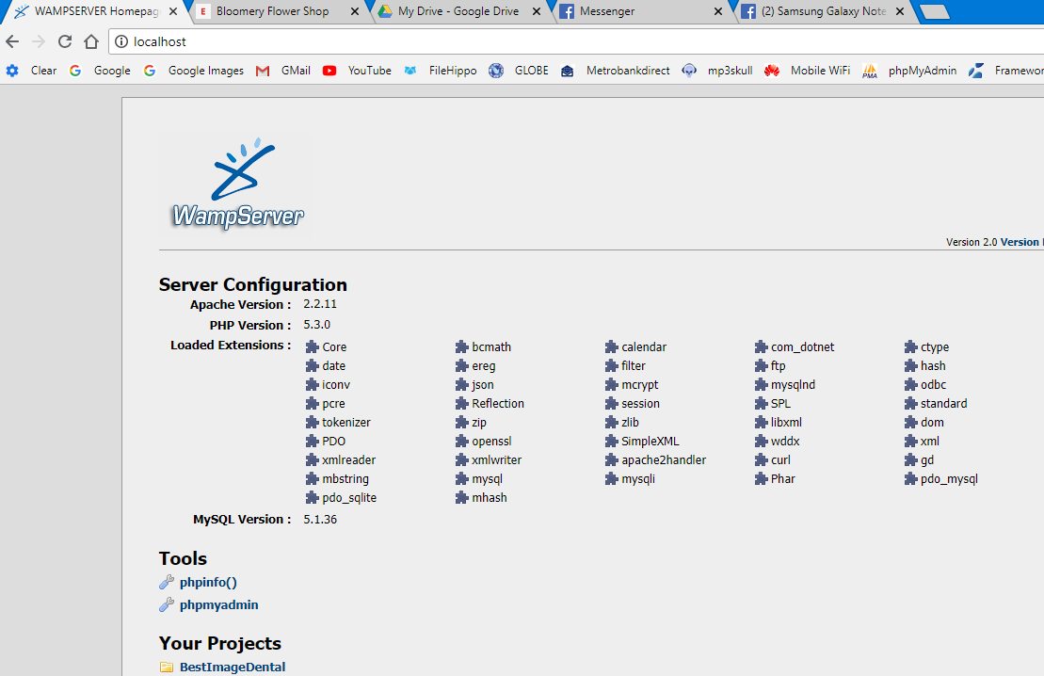

1. Click **phpMyAdmin** under **Tools**
2. Create new database and name it “**dbopc**”

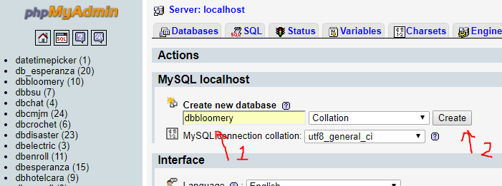

1. Click **Import** and click **Choose file**. Select “**dbopc.sql**” file inside the extracted folder then click **Go**.

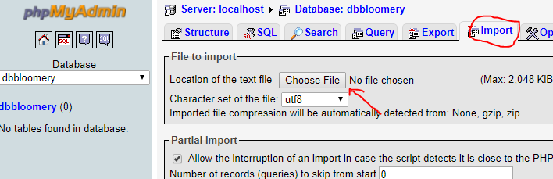

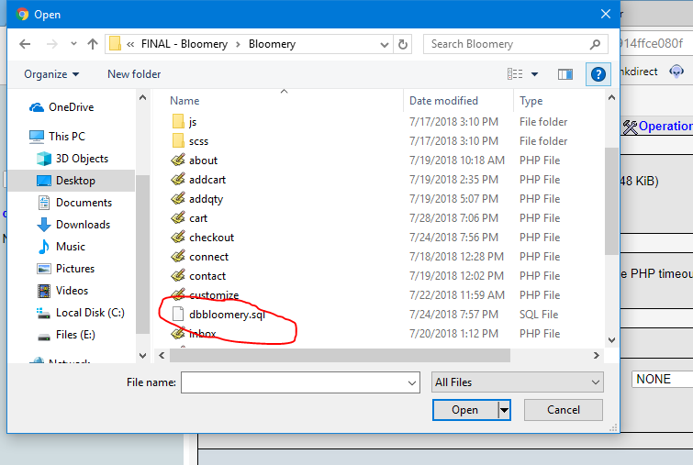

1. Now, go to “**localhost**” again and select **OnlinePersonalCounseling** under **My Projects**

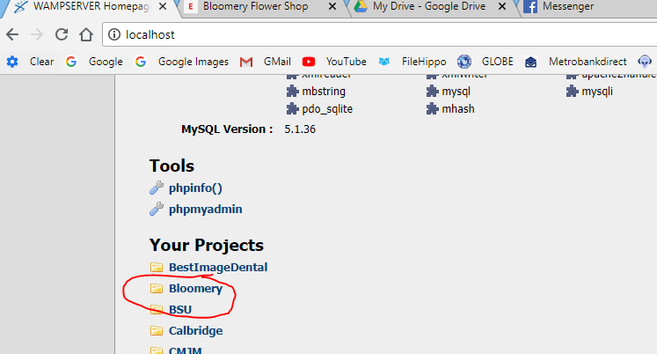

**Notes:**

1. To access admin page, go to **localhost/Lakan/admin**
2. Username is **admin** and default admin password is **11111111**
3. Whenever you need to access your system, make sure that the WampServer is running (with White icon)